DDL,DML COMMANDS AND THEIR EXECUTION.

DDL-DATA DEFINITION LANGUAGE

DML-DATA MANUPULATION LANGUAGE

1. DDL COMMANDS:
2. create table
3. Alter table
4. Drop table
5. Truncate table
6. DML COMMANDS:
7. Update
8. Delete
9. Insert
10. Select
11. **create table:**

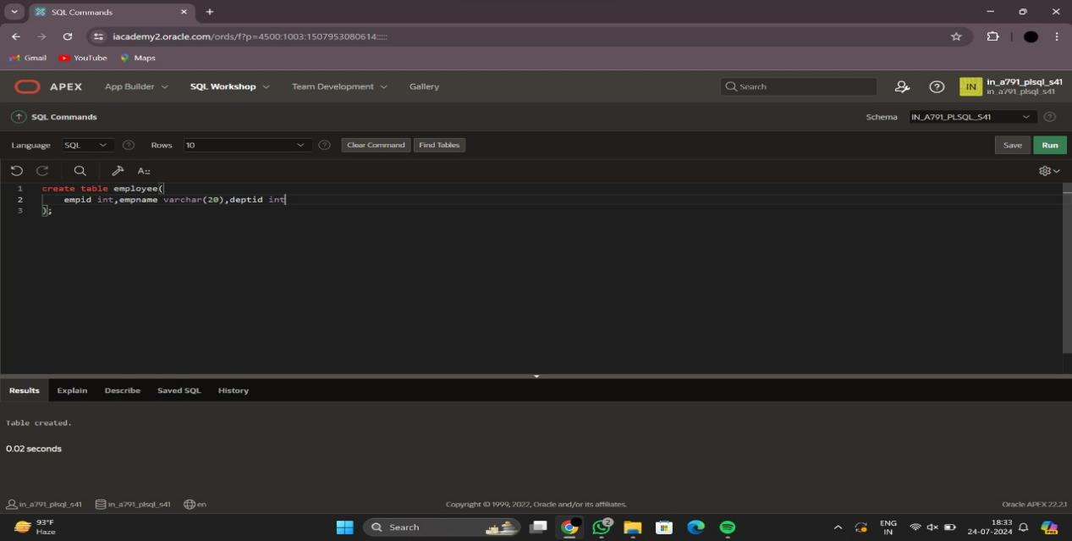

1. desc table:

This is used to describe the table and its attributes after the creating the table we can see the table by using describe table.

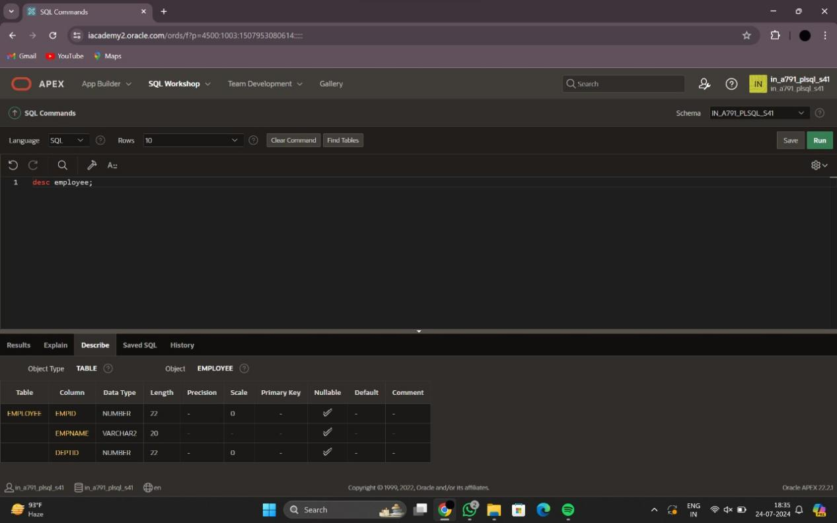

1. insert command:

Insert into employee

Values(101,’haneesh’,1);

By above method we can insert the values into table as records as how many we needed.

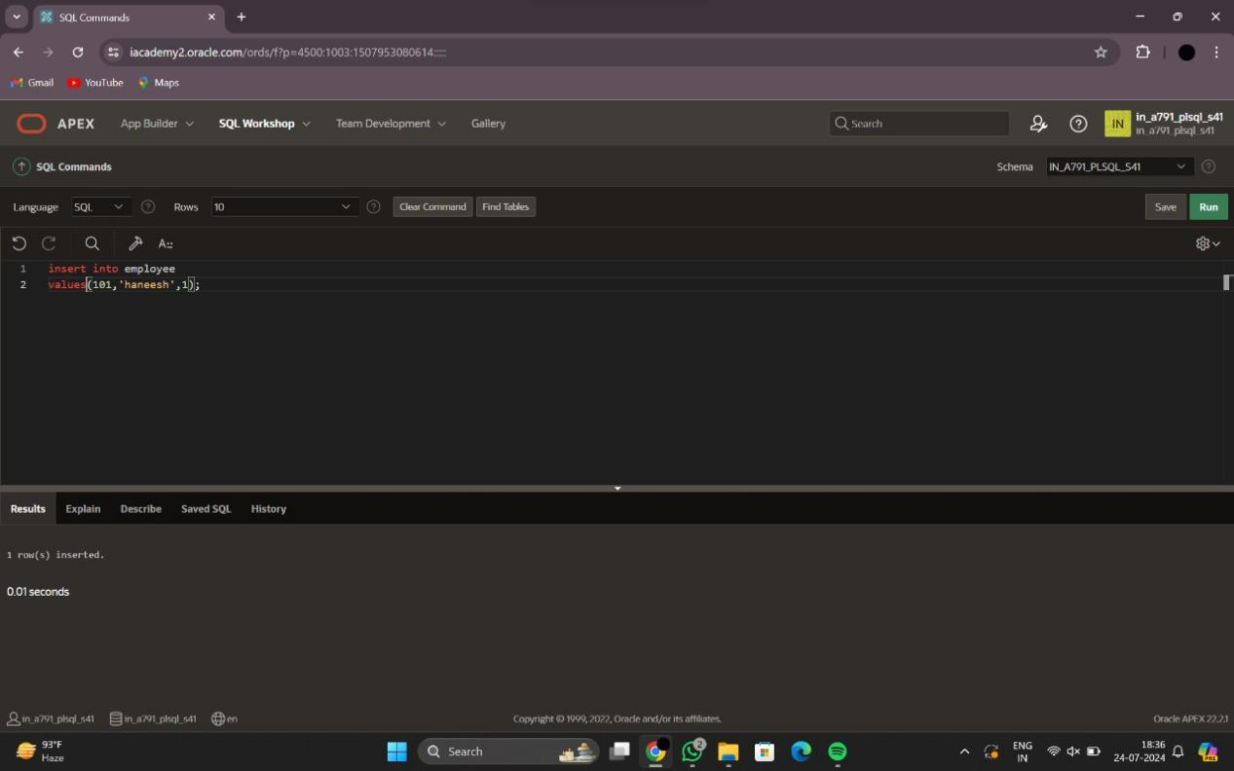

1. select command:

To see all the records in table we use this command as

select * from tablename;

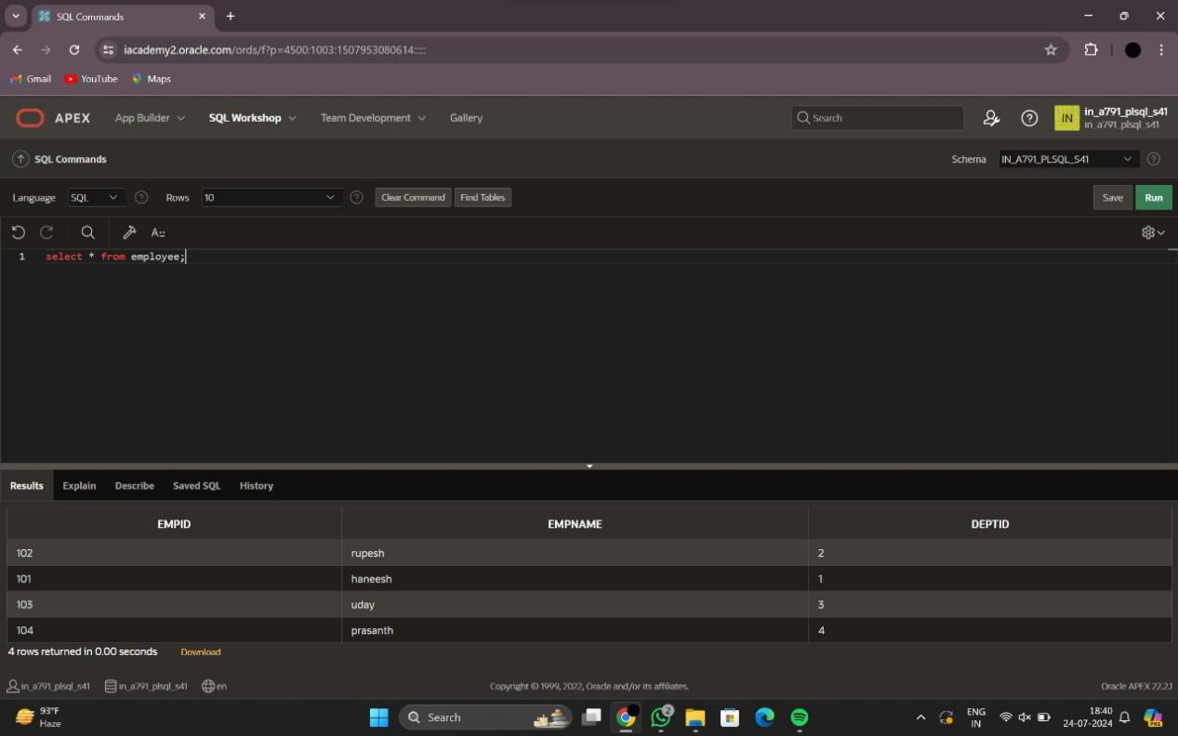

1. Alter table command:

Alter table tablename add coloum name;

For employee table :

Alter table employee add yearofjoin;

After execution to display with records using select command.

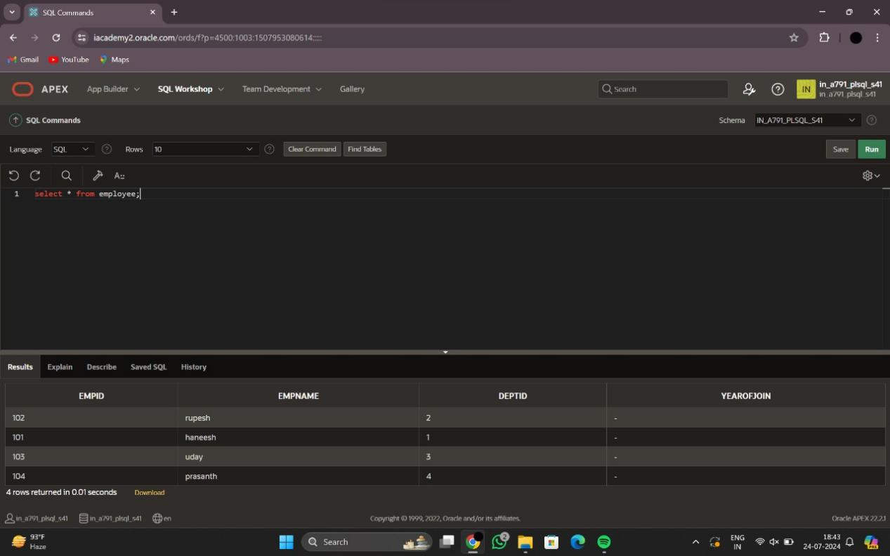

1. update table:

Update tablename

Set condition

Where updationcoloum or id;

For employee table:

Update employee

set yearofjoin=2019

Where empid=101;

As this we can update for all the records.

After updation the result as follows:

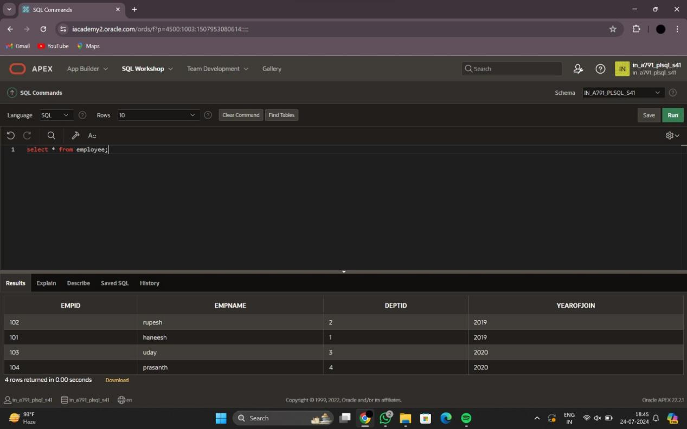

1. Delete command:

Delete tablename

Where condition;

If we want delete particular record in a table as follows:

Delete employee

Where empid=104;

After execution: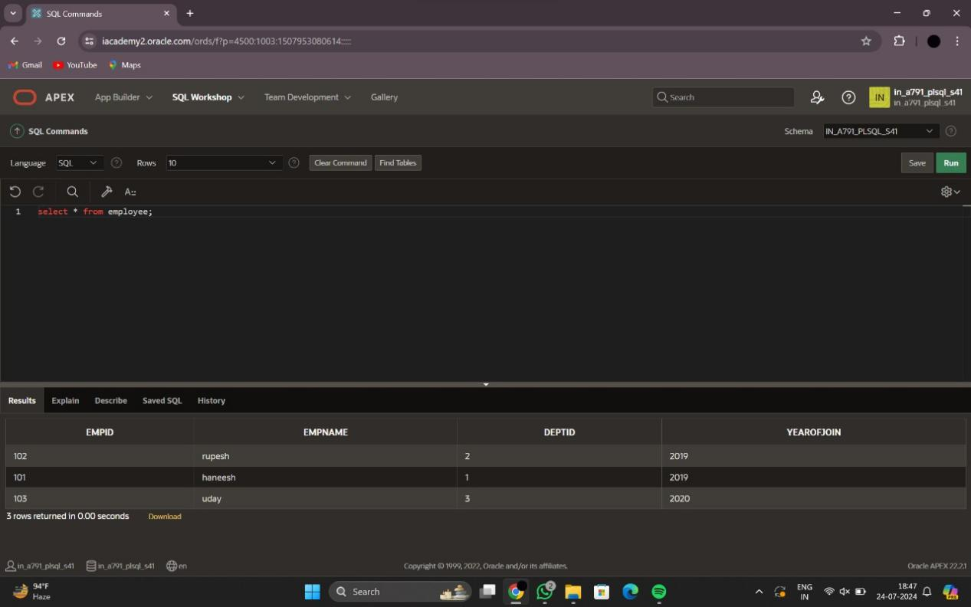

Let us alter the table and add the salary for all the records using updation and after completion it looks like:

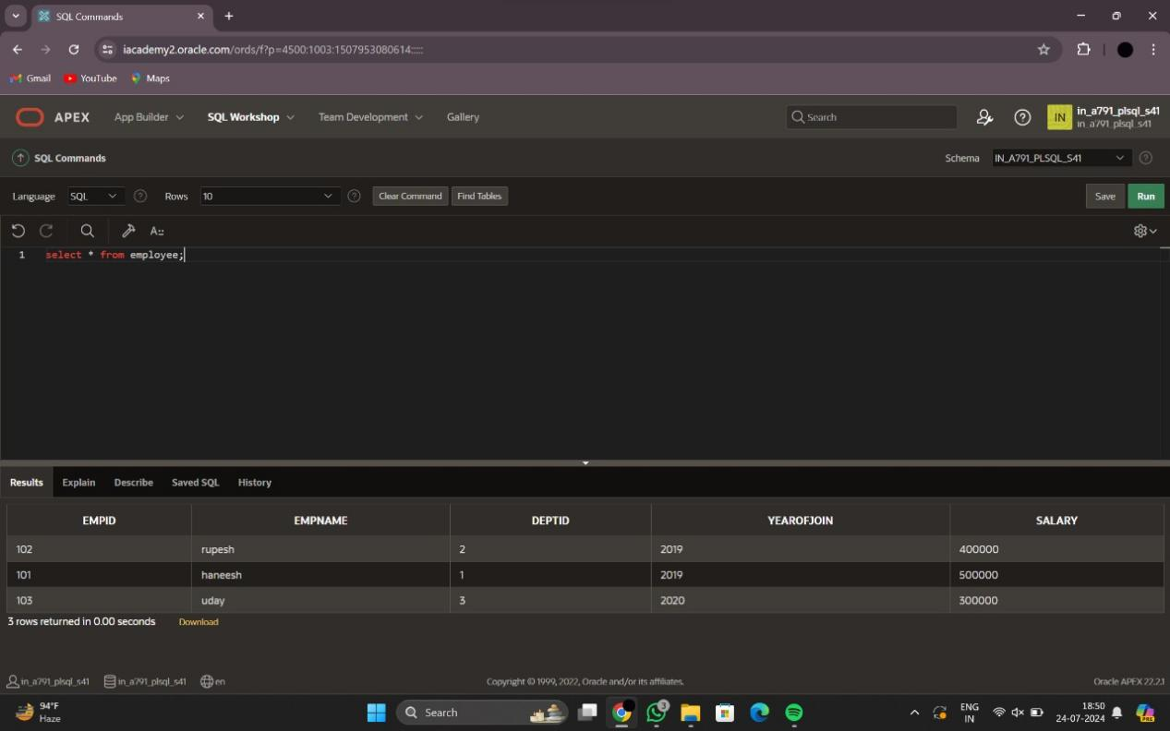

1. min():

Select min(salary)

From employee;

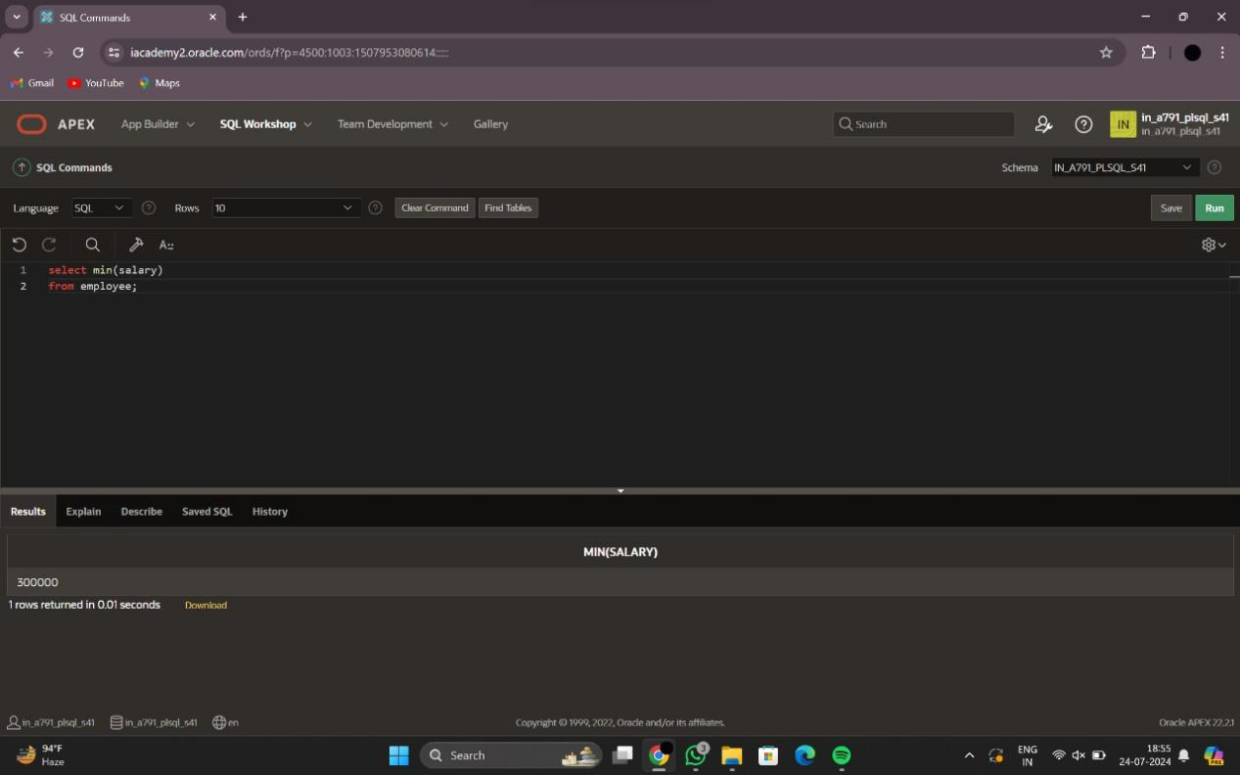

1. max():

Select max(salary)

From employee;

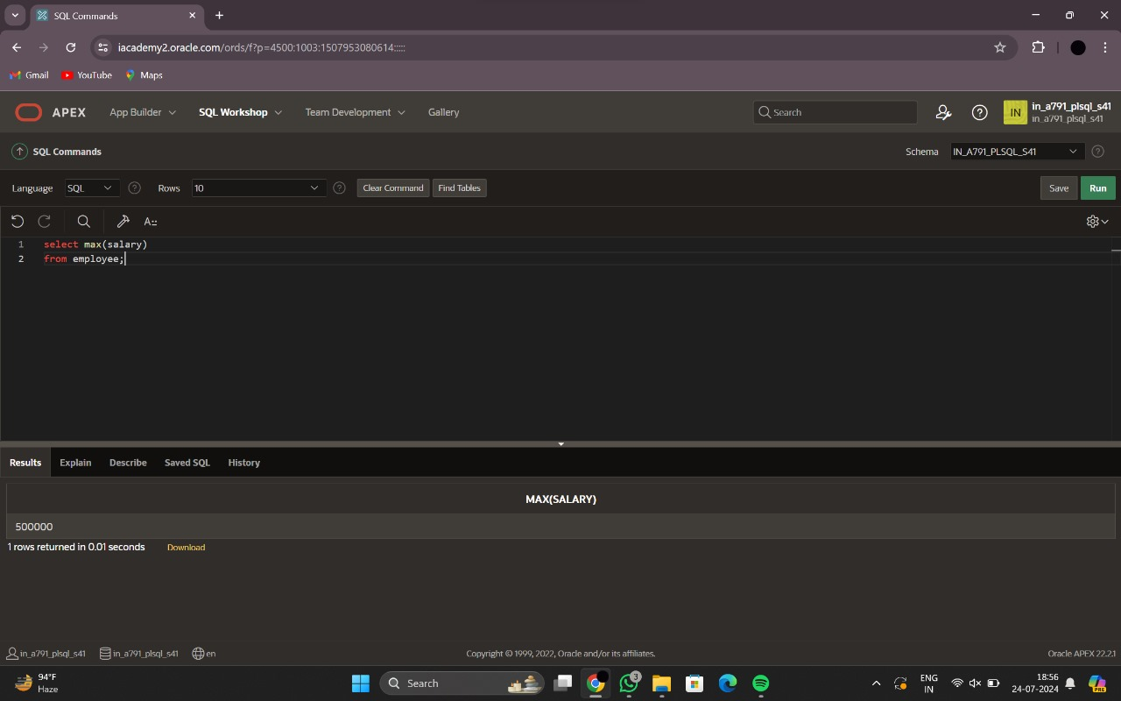

1. avg():

Select avg(salary)

From employee;

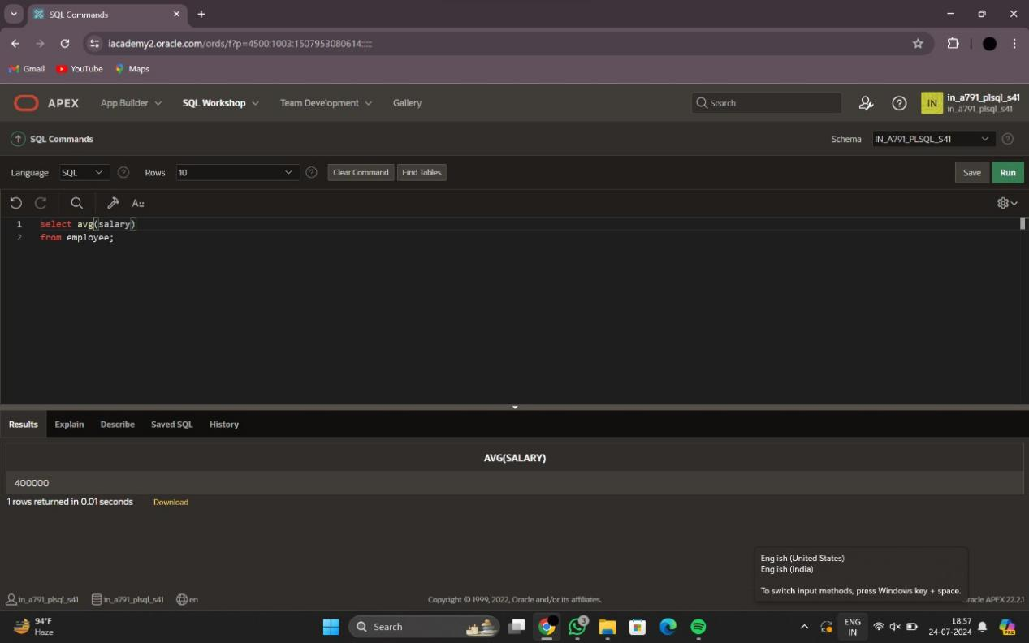

1. sum():

Select sum(salary)

From employee;

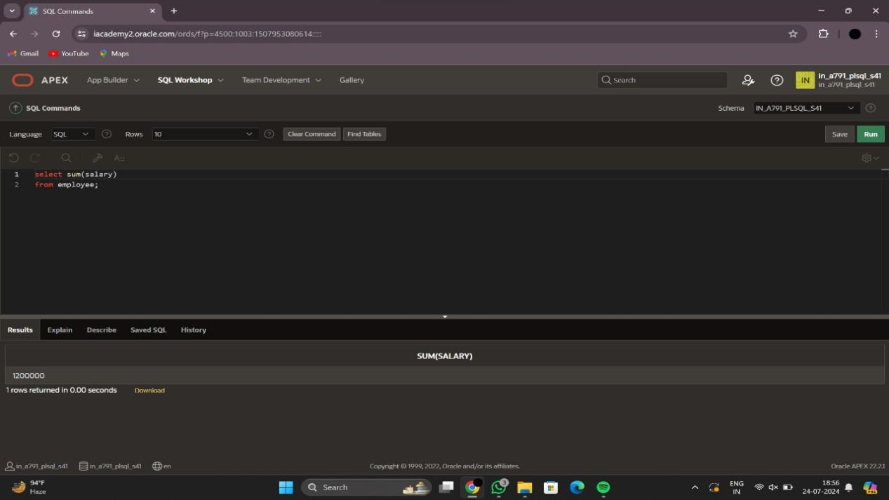

1. count():

select count(*)

From employee;

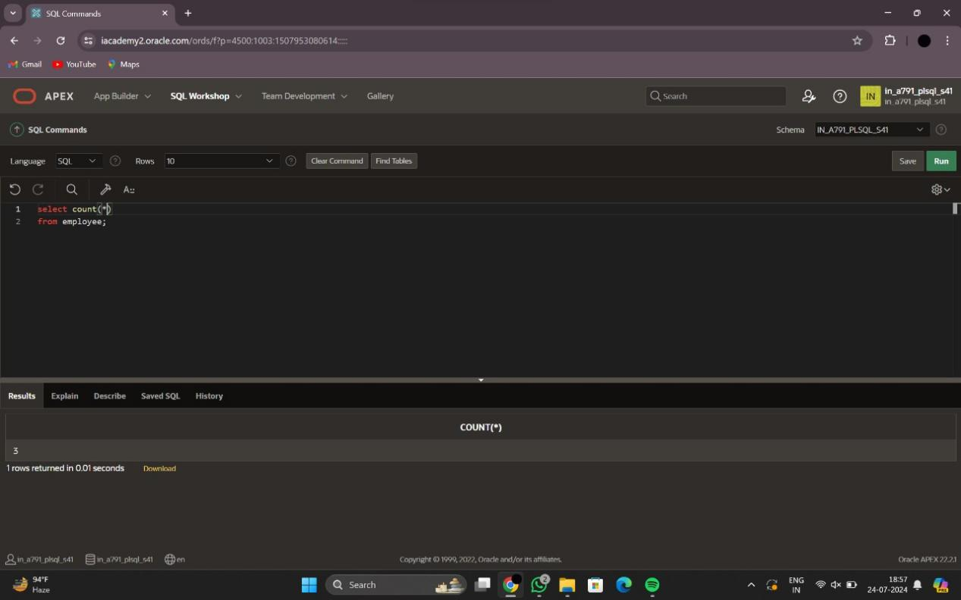

1. order by:

select * from employee

Order by empid;

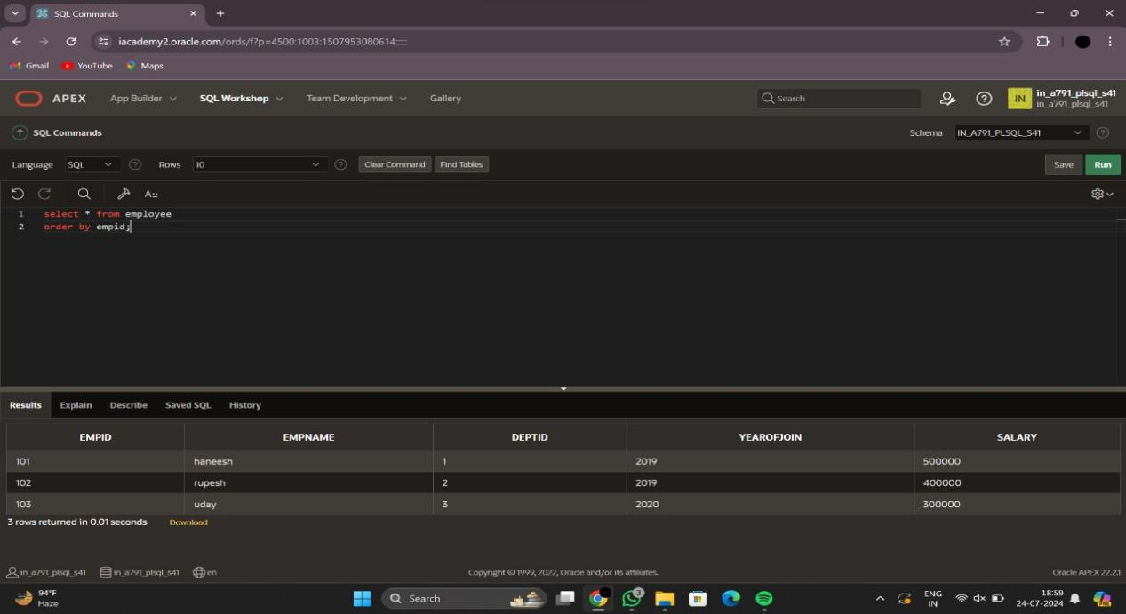

1. Truncate table:

Truncate table tablename;

Truncate table employee;

All the records will be deleted only table structure.

1. Drop table:

Drop table tablename;

Drop table employee;

All the data will be erased with all table name will be not found.